ELEC 2210 Fall 2020

Lab 7 Quiz

Name: Jacob Howard

Section: *002*

1. What are the 3 terminals of a bipolar junction transistor? (Circle one)

A. Drain, Source, Gate

B. Collector, Base, Emitter (This one)

C. Collector, Gate, Source

D. Drain, Base, Source

1. The plot below shows the output characteristics of a BJT. Identify which region (A through D) on the plot is the cutoff region, the saturation region, the forward-active region, and the reverse-active region

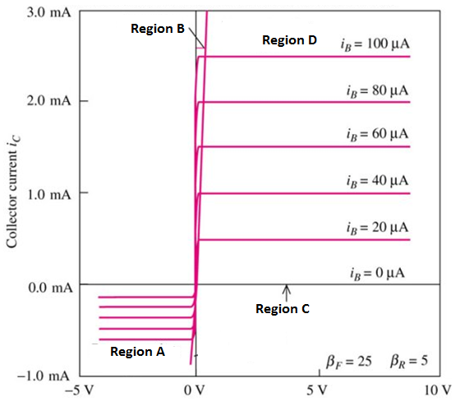

Region A: Reverse Active

Region B: Saturation

Region C: Cutoff

Region D: Forward Active